Cecil Andrews College

Unit 3 ATAR Human Biology

Name:____________________________________________________________________

Test 3: The Immune system

|  |  |  |
| --- | --- | --- |
| Section | Marks available | Marks Achieved |
| A  Multiple Choice | 10 |  |
| B  Short Answer | 35 |  |
| C  Extended Answer | 10 |  |

**ATAR Human Biological Science Unit 3**

**Immune System**

Place a **X** through the best answer.

|  |  |  |  |  |  |
| --- | --- | --- | --- | --- | --- |
| **1** |  | (a) | (b) | ( c) | (d) |
| **2** |  | (a) | (b) | ( c) | (d) |
| **3** |  | (a) | (b) | ( c) | (d) |
| **4** |  | (a) | (b) | ( c) | (d) |
| **5** |  | (a) | (b) | ( c) | (d) |
| **6** |  | (a) | (b) | ( c) | (d) |
| **7** |  | (a) | (b) | ( c) | (d) |
| **8** |  | (a) | (b) | ( c) | (d) |
| **9** |  | (a) | (b) | ( c) | (d) |
| **10** |  | (a) | (b) | ( c) | (d) |
|  |  |  |  |  |  |
|  |  |  |  |  |  |
|  |  |  |  |  |  |
|  |  |  |  |  |  |
|  |  |  |  |  |  |

Section B: Short Answer

(35 marks)

Question 11 (11 marks)

The following question refers to the diagram shown below, which represents some of the

external defences to infection of the human body.

(a) In each box, explain how the structure indicated provides protection from infection.

(6 marks)

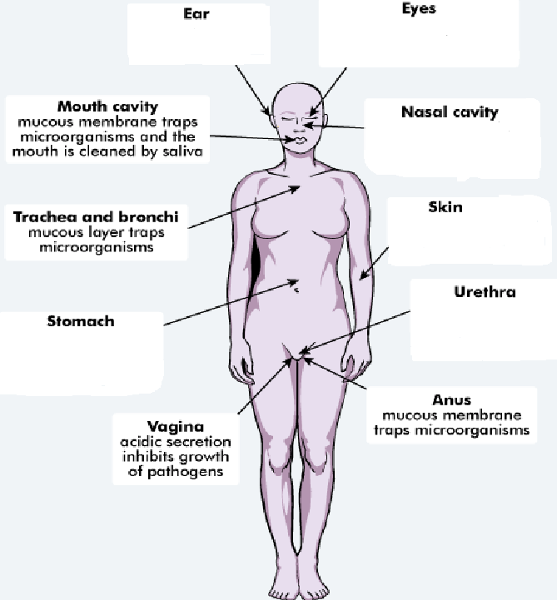

(b) An important strategy to reduce spread of infection is good personal hygiene.

List two strategies a person should follow to ensure good personal hygiene. (2 marks)

One:__________________________________________________________________________________________________________________________________________________________________________________________________________

Two:___________________________________________________________________________________________________________________________________________________________________________________________________________

(c) Inflammation is often a response displayed by the body when a pathogen has entered it.

Complete the table below, describing the action of each listed substance in the

inflammatory response. (3 marks)

|  |  |
| --- | --- |
|  | **Role in Inflammatory Response** |
| Heparin |  |
| Histamine |  |
| Phagocytes |  |

Question 12 (10 marks)

(a) Immunity can be classed as passive or active and natural or artificial. Complete the table

below, describing the different types of immunity. (4 marks)

|  |  |  |
| --- | --- | --- |
|  | Passive | Active |
| Natural |  |  |
| Artificial |  |  |

(b) The diagram below shows one of the actions of antibodies on pathogens.

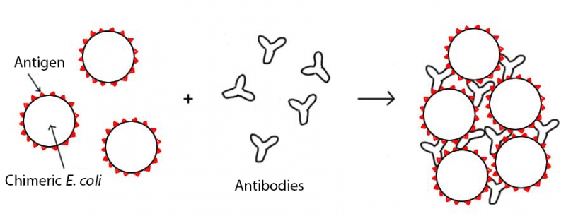

1. What action of antibodies does the diagram represent? (1 mark)

______________________________________________________________________________________________________________

(ii) Describe three other ways in which antibodies can act on pathogens to help fight

infection. (3 marks)

One:_____________________________________________________________________________________________________________________________________________________________________________________________________

Two:______________________________________________________________________________________________________________________________________________________________________________________________________

Three:____________________________________________________________________________________________________________________________________________________________________________________________________

(iii) Name the type of lymphocyte responsible for the production of antibodies.

________________________________________________________________________________________________(1 mark)

(c) Vaccines are considered a safe and reliable way of increasing the immunity of

populations. However, there are risks associated with vaccines.

Identify one risk associated with the production or use of vaccines.

___________________________________________________________________________________________________________ (1 mark)

Question 13 (14marks)

In the first few years of their life, babies and young children are attacked by many pathogens. Yet, they remain healthy and are well able to defeat and survive these pathogens. This is a result of the combined action of their Non-Specific Immune System, Passive Immunity and Active Immunity.

(a) Define the following terms and provide an example of each:

Pathogen: (2 marks)

__________________________________________________________________________________________________________________________________________________________________________________________________________________________________________________________________________________________________________________

Non-Specific Immune System: (2 marks)  
__________________________________________________________________________________________________________________________________________________________________________________________________________________________________________________________________________________________________________________

Artificial Passive Immunity: (2 marks)  
__________________________________________________________________________________________________________________________________________________________________________________________________________________________________________________________________________________________________________________

In 2004, as part of the government’s public health programme, many children of school age were vaccinated against the disease whooping cough.

(b) On the axes presented below **draw** and **label** clearly the antibody response for a child who has been vaccinated against whooping cough andsubsequently is exposed to this disease. (4 marks)

(c) Identify two different types of vaccine based on the substance they contain to cause an immune response. (2 mark)

____________________________________________________________________________________________________________________________________________________________________________________________________________

(d) What is herd immunity? How does herd immunity protect individuals from contracting diseases?   
 (2 marks)  
__________________________________________________________________________________________________________________________________________________________________________________________________________________________________________________________________________________________________________________

Section C: Choose **ONE** of the two extended answer questions and write a response on the paper provided

Question 16. (10 marks)

1. Multiple drug resistant bacteria are becoming a problem in treating some bacterial infections. Bacteria that have evolved resistance to antibiotics cannot be controlled or treated

Researchers have suggested that the overuse of antibiotics in the community has caused the evolution of generations of multiple drug resistant bacteria. Explain how this resistance would occur if three antibiotics, A, B and C were used in sequence to treat a bacterial infection. (10 marks)

Question 17.

1. marks)
2. Antibiotics can be used to treat bacterial infections but are generally not effective against viral infections
3. Outline the reasons why antibiotics are ineffective against viral infections (3 marks)
4. What is an antiviral? Describe how antivirals work. (2 marks)
5. John was not immunised against whooping cough when he was an infant. As a teenager he was exposed to the pathogen that caused the disease and became ill. Jennifer was vaccinated as an infant and when exposed as a teenager she did not contract the disease and showed only very minor symptoms.
6. Explain the difference between Jennifer’s response and John’s response when they were exposed as teenagers to the pathogen (5 marks)